**TRAINING REPORT ON EMBEDDED SYSTEMS AND ROBOTICS**

A Report submitted in partial fulfilment of the requirement for the award of degree of

Bachelor of Technology

In

Electronics and Communication Engineering

Submitted by

VIBHOR KATARIA (42215002817)



**MAHARAJA SURAJMAL INSTITUTE OF TECHNOLOGY**

C-4, Janakpuri, New Delhi-58

Affiliated to Guru Gobind Singh Indraprastha University, Delhi

JULY, 2019

**ACKNOWLEDGEMENT**

A research work owes its success from commencement to completion, to the people in love with researchers at various stages. Let me in this page express my gratitude to all those who helped us in various stage of this study. First, I would like to express my sincere gratitude indebtedness to **Mr. Puneet Azad**(HOD, Department of Electronics and communication, Maharaja Surajmal Institute of Technology, New Delhi) for allowing me to undergo the summer training of 6 weeks at Kyrion Technologies & Hewlett Packard Enterprise.

I am grateful to our guide **Mr. Ashish Saini** for the help provided in completion of the project, which was assigned to me. Without his friendly help and guidance it was difficult to develop this project.

Last but not least, I pay my sincere thanks and gratitude to all the Staff Members of **Kyrion Technologies** for their support and for making our training valuable and fruitful.

# Contents

Abstract…………………………………………………………………..6

Chapter 1: Introduction…………………………..7

1.1 Embedded Systems …………7

1.2 Robotics……………………..8

Chapter 2: Microcontrollers, Components, Sensors used…………….9

2.1 Arduino UNO………………9

2.2 LED……………………………….10

2.3 DC Motor………………………….11

2.4 Motor Driver……………………….11

2.5 Touch Sensor……………………….12

2.6 IR Sensor…………………………...12

2.7 PIR Sensor………………………….13

2.8 GPS…………………………………13

2.9 LDR…………………………………14

2.10 Relay……………………………….14

2.11 DHT11 Sensor……………………..15

2.12 MPU6050…………………………..15

2.13 Keypad Matrix……………………...16

2.14 RF Module………………………….16

Chapter 3: Smart Home……………………………………………………….17

3.1 Soil Moisture Detection………………………….18

3.2 Security System Using Keypad Matrix…………..21

3.3 Curtain Raiser Using LDR……………………….23

3.4 Automatic door using PIR Sensor………………..25

3.5 Temperature and Humidity Detection……………27

Bibliography…………………………………………………………………29

**ABSTRACT**

The main objective of this project is to make home automation system using an Arduino board. As technology is advancing so houses are also getting smarter. Modern houses are gradually shifting from conventional switches to centralized control system. This helps elderly as well as handicapped people in operating and provides them comfort.

Computer controlled sensors allow the home read information about people, objects, conditions in the smart home environment. General functions provided by a smart home include safety , security, health monitoring, notification of emergencies, memory aids and task assistance.

Moreover , with the rapid expansion of the internet there is a potential for the remote control and monitoring of such network enabled devices.

**INTRODUCTION TO EMBEDED SYSTEMS AND ROBOTICS**

# EMBEDDED SYSTEMS

An embedded system is a combination of computer hardware and software, either fixed in capability or programmable, designed for a specific function or functions within a larger system. Industrial machines, agricultural and process industry devices, automobiles, medical equipment, cameras, household appliances, airplanes, vending machines and toys, as well as mobile devices, are possible locations for an embedded system.

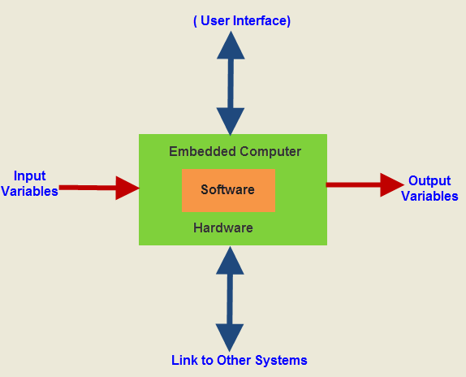

Embedded systems are computing systems, but they can range from having no user interface ([UI](https://searchmicroservices.techtarget.com/definition/user-interface-UI)) -- for example, on devices in which the system is designed to perform a single task -- to complex graphical user interfaces ([GUIs](https://searchwindevelopment.techtarget.com/definition/GUI)), such as in mobile devices. User interfaces can include buttons, User interfaces can include buttons, LEDs, touchscreen sensing and more. Some systems use remote user interfaces as well.

**ROBOTICS**

Robotics is a branch of engineering that involves the conception, design, manufacture, and operation of [robots](https://searchenterpriseai.techtarget.com/definition/robot). This field overlaps with electronics, computer science, [artificial intelligence](https://searchenterpriseai.techtarget.com/definition/AI-Artificial-Intelligence), mechatronics, [nanotechnology](https://whatis.techtarget.com/definition/nanotechnology-molecular-manufacturing) and bioengineering.

Science-fiction author Isaac Asimov is often given credit for being the first person to use the term robotics in a short story composed in the 1940s. In the story, Asimov suggested three principles to guide the behavior of robots and smart machines. Asimov's Three Laws of Robotics, as they are called, have survived to the present:

* Robots must never harm human beings.
* Robots must follow instructions from humans without violating rule
* Robots must protect themselves without violating the other rules.



**MICROCONTROLLERS, COMPONENTS, SENSORS USED**

* **Arduino UNO:**

The **Arduino Uno** is an [open-source](https://en.wikipedia.org/wiki/Open-source) [microcontroller board](https://en.wikipedia.org/wiki/Microcontroller_board) based on the [Microchip](https://en.wikipedia.org/wiki/Microchip_Technology) [ATmega328P](https://en.wikipedia.org/wiki/ATmega328P) microcontroller and developed by [Arduino.cc](https://en.wikipedia.org/wiki/Arduino). The board is equipped with sets of digital and analog [input/output](https://en.wikipedia.org/wiki/Input/output) (I/O) pins that may be interfaced to various [expansion boards](https://en.wikipedia.org/wiki/Expansion_board) (shields) and other circuits. The board has 14 Digital pins, 6 Analog pins, and programmable with the [Arduino IDE](https://en.wikipedia.org/wiki/Arduino#Software) (Integrated Development Environment) via a type B [USB cable](https://en.wikipedia.org/wiki/USB_cable). It can be powered by the USB cable or by an external [9-volt battery](https://en.wikipedia.org/wiki/9-volt_battery), though it accepts voltages between 7 and 20 volts. It is also similar to the [Arduino Nano](https://en.wikipedia.org/wiki/Arduino_Nano) and Leonardo. The hardware reference design is distributed under a [Creative Commons](https://en.wikipedia.org/wiki/Creative_Commons) Attribution Share-Alike 2.5 license and is available on the Arduino website. Layout and production files for some versions of the hardware are also available.

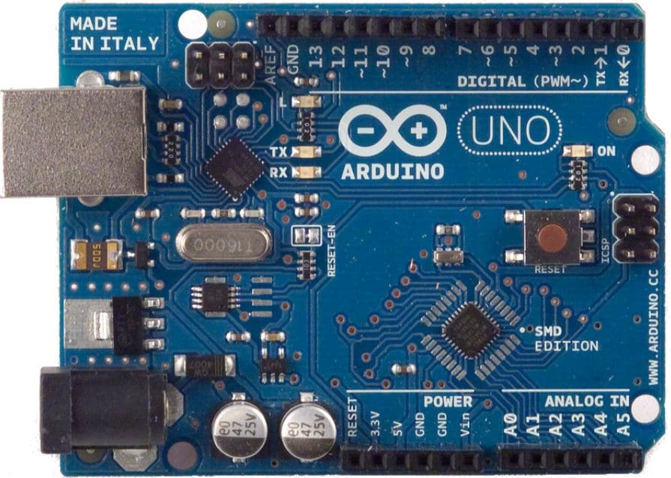

* **LED:**

A **light-emitting diode** (**LED**) is a [semiconductor](https://en.wikipedia.org/wiki/Semiconductor) [light source](https://en.wikipedia.org/wiki/Light_source) that emits light when [current](https://en.wikipedia.org/wiki/Electric_current) flows through it. [Electrons](https://en.wikipedia.org/wiki/Electron) in the semiconductor recombine with [electron holes](https://en.wikipedia.org/wiki/Electron_hole), releasing energy in the form of [photons](https://en.wikipedia.org/wiki/Photon). The color of the light (corresponding to the energy of the photons) is determined by the energy required for electrons to cross the [band gap](https://en.wikipedia.org/wiki/Band_gap) of the semiconductor.

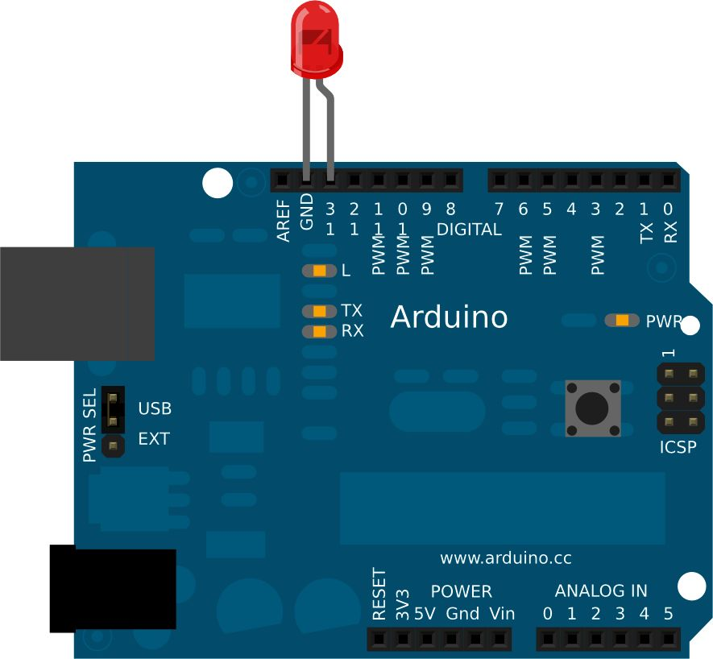

* **SOIL MOISTURE SENSOR**

The Soil Moisture Sensor uses capacitance to measure the water content of soil (by measuring the dielectric permittivity of the soil, which is a function of the water content). Simply insert this rugged sensor into the soil to be tested, and the volumetric water content of the soil is reported in percent.

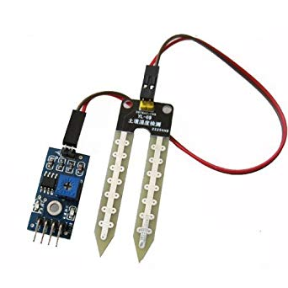

* **DC MOTOR:**

An electric motor is an electrical machine which converts electrical energy into mechanical energy. The basic working principle of a DC motor is: "whenever a current carrying conductor is placed in a magnetic field, it experiences a mechanical force".

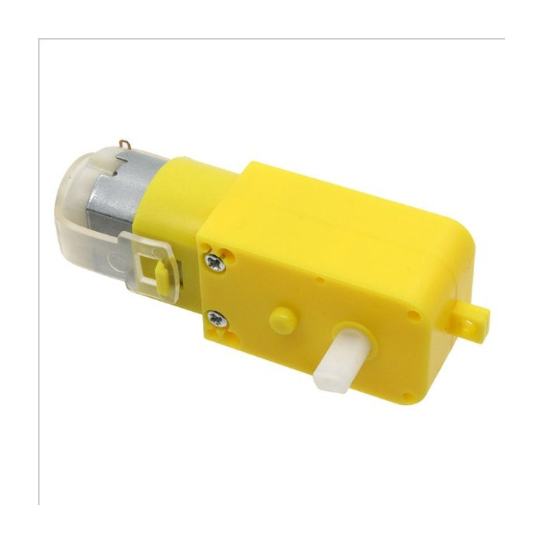

* **MOTOR DRIVER(L293D):**

L293D is a typical Motor driver or Motor Driver IC which allows DC motor to drive on either direction. L293D is a 16-pin IC which can control a set of two DC motors simultaneously in any direction. It means that you can control two DC motor with a single L293D IC.

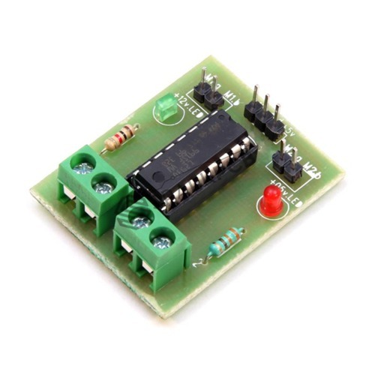

* **TOUCH SENSOR:**

A touch sensor is a type of equipment that captures and records physical touch or embrace on a device and/or object. It enables a device or object to detect touch, typically by a human user or operator. A touch sensor may also be called a touch detector.

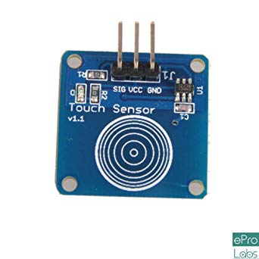

* **IR SENSOR:**

An infrared sensor is an electronic device that emits in order to sense some aspects of the surroundings. An IR sensor can measure the heat of an object as well as detects the motion. The IR transmitter sends an infrared signal that, in case of a reflecting surface (e.g. white color), bounces off in some directions including that of the IR receiver that captures the signal detecting the object.

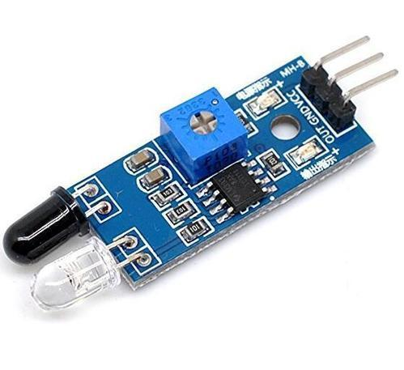

* **PIR SENSOR:**

A passive infrared sensor (PIR sensor) is an electronic sensor that measures infrared (IR) light radiating from objects in its field of view. They are most often used in PIR-based motion detectors.

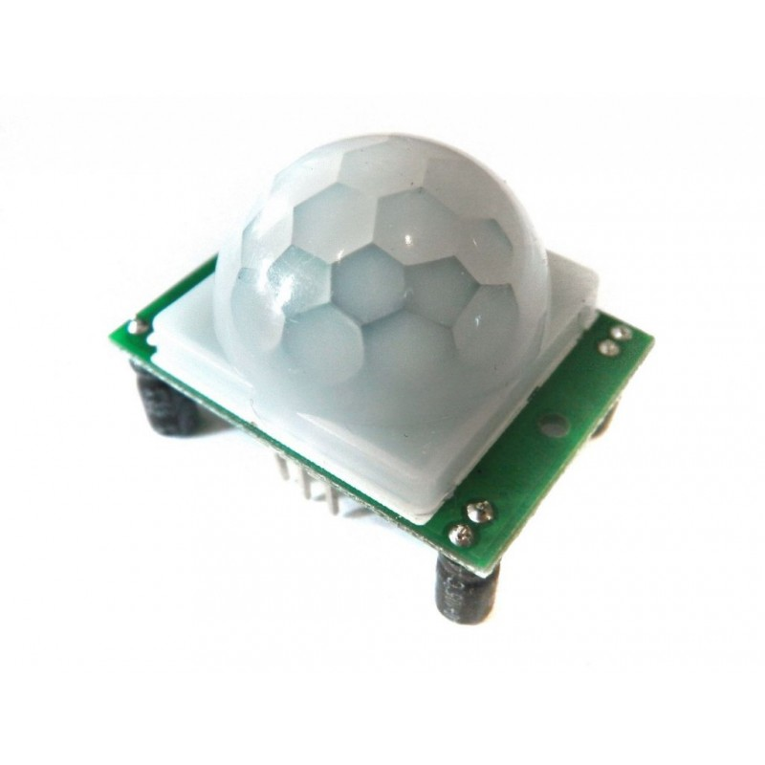

* **GPS:**

To connect GPS module to Arduino, we use a +5V from the power side of the Arduino and any ground pin. Any two pins will work for the serial communication, we will use 3 and 4:

* Connect Arduino pin 3 to the RX pin of the GPS Module.
* Connect Arduino pin 4 to the TX pin of the GPS Module.

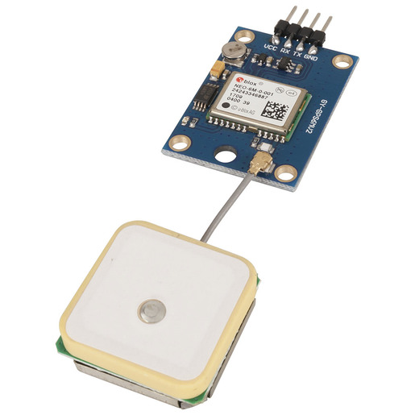

* **LDR(LIGHT DEPENDENT RESISTOR):**

A Light Dependent Resistor (LDR) or a photo resistor is a device whose resistivity is a function of the incident electromagnetic radiation. Hence, they are light sensitive devices. They are also called as photo conductors, photo conductive cells or simply photocells.

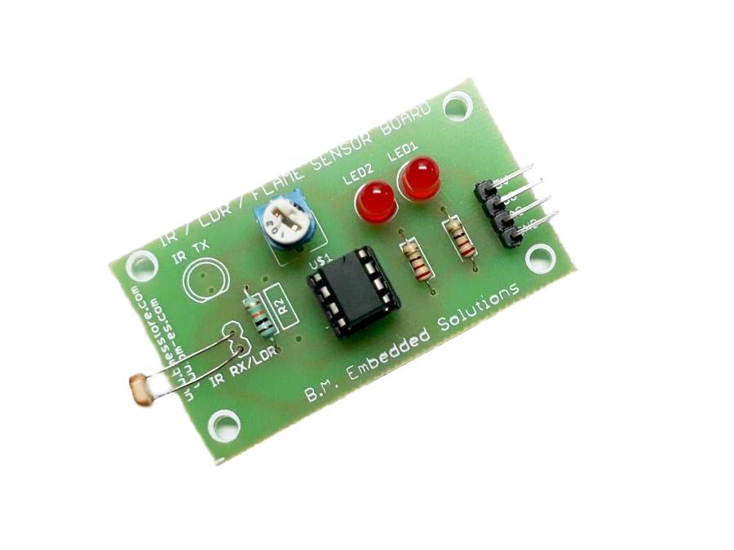

* **RELAY:**

Relays are switches that open and close circuits electromechanically or electronically. Relays control one electrical circuit by opening and closing contacts in another circuit. As relay diagrams show, when a relay contact is normally open (NO), there is an open contact when the relay is not energized and is normally closed when connections are made at (NC).

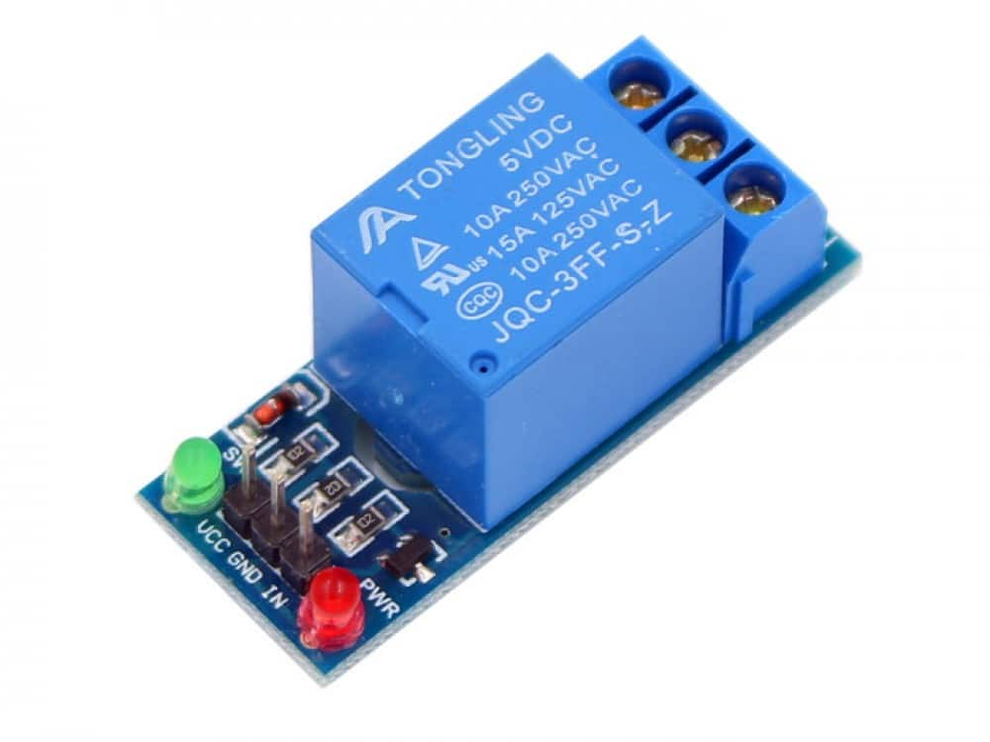

* **DHT 11 SENSOR:**

The **DHT11**is a commonly used **Temperature and humidity sensor.** The sensor comes with a dedicated NTC to measure temperature and an 8-bit microcontroller to output the values of temperature and humidity as serial data. The sensor is also factory calibrated and hence easy to interface with other microcontrollers.

The sensor can measure temperature from 0°C to 50°C and humidity from 20% to 90% with an accuracy of ±1°C and ±1%.

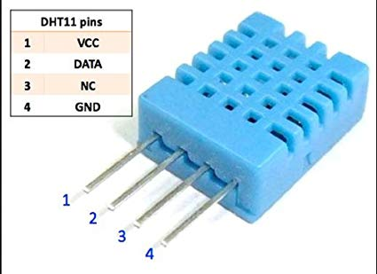

* **MPU6050:**

MPU6050 sensor module is complete 6-axis Motion Tracking Device. It combines 3-axis Gyroscope, 3-axis Accelerometer and Digital Motion Processor all in small package. Also, it has additional feature of on-chip Temperature sensor. It has I2C bus interface to communicate with the microcontrollers.

It has Auxiliary I2C bus to communicate with other sensor devices like 3-axis Magnetometer, Pressure sensor etc.

If 3-axis Magnetometer is connected to auxiliary I2C bus, then MPU6050 can provide complete 9-axis Motion Fusion output.

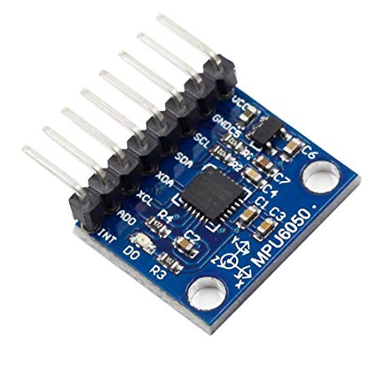

* **KEYPAD MATRIX:**

Matrix keypads use a combination of four rows and four columns to provide button states to the host device, typically a microcontroller. Underneath each key is a pushbutton, with one end connected to one row, and the other end connected to one column.

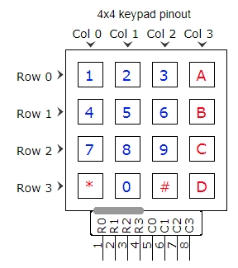

* **RF MODULE:**

An RF module (radio frequency module) is a (usually) small electronic device used to transmit and/or receive radio signals between two devices. In an [embedded system](https://en.wikipedia.org/wiki/Embedded_system) it is often desirable to communicate with another device [wirelessly](https://en.wikipedia.org/wiki/Wireless). This wireless communication may be accomplished through [optical communication](https://en.wikipedia.org/wiki/Free-space_optical_communication) or through [radio](https://en.wikipedia.org/wiki/Radio) frequency (RF) communication. For many applications the medium of choice is RF since it does not require line of sight.

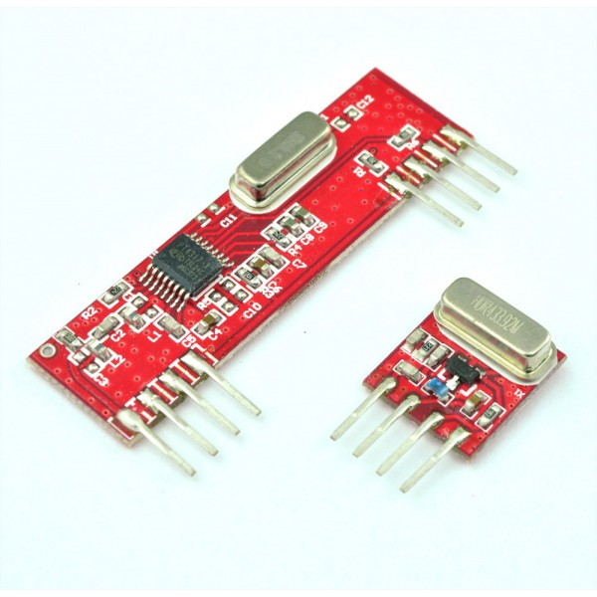

SMART HOME

**SOIL MOISTURE DETECTION**

**Aim: To check the soil moisture of a field and irrigate it automatically when in need.**

**Requirements for the model:**

1. Soil moisture sensor
2. Arduino UNO.
3. Jumper wires
4. Servomotor
5. USB cable
6. Breadboard
7. 9V battery snap
8. Soil in some amount
9. Water tank
10. Water
11. 16x2 LCD display
12. 5V Dc motor
13. 221 ohm resistor
14. 15. General purpose transistor NPN
15. 1N4007 diode

**Utility of the model:**

 We used to get worried about our plants because they need water on regular basis. I have gone through several options to solve this problem as plants need water according to the moisture level of soil. So I have made **Automatic Plant Watering System Using Arduino UNO.**

**Working of the model:**

The soil moisture sensor will take the readings from the soil bed and keep showing them at the LCD display. When the soil moisture level is dry (or low) the servomotor will start automatically to provide the water flow from the load tank to the soil bed.  I made a 5V DC motor based water pump using diode, transistor and registers combined circuit which operates DC motor according to the Arduino code

After the water flow when soil is not dry and is fulfilled with enough moisture the water flow stops along with the water flow by itself only.

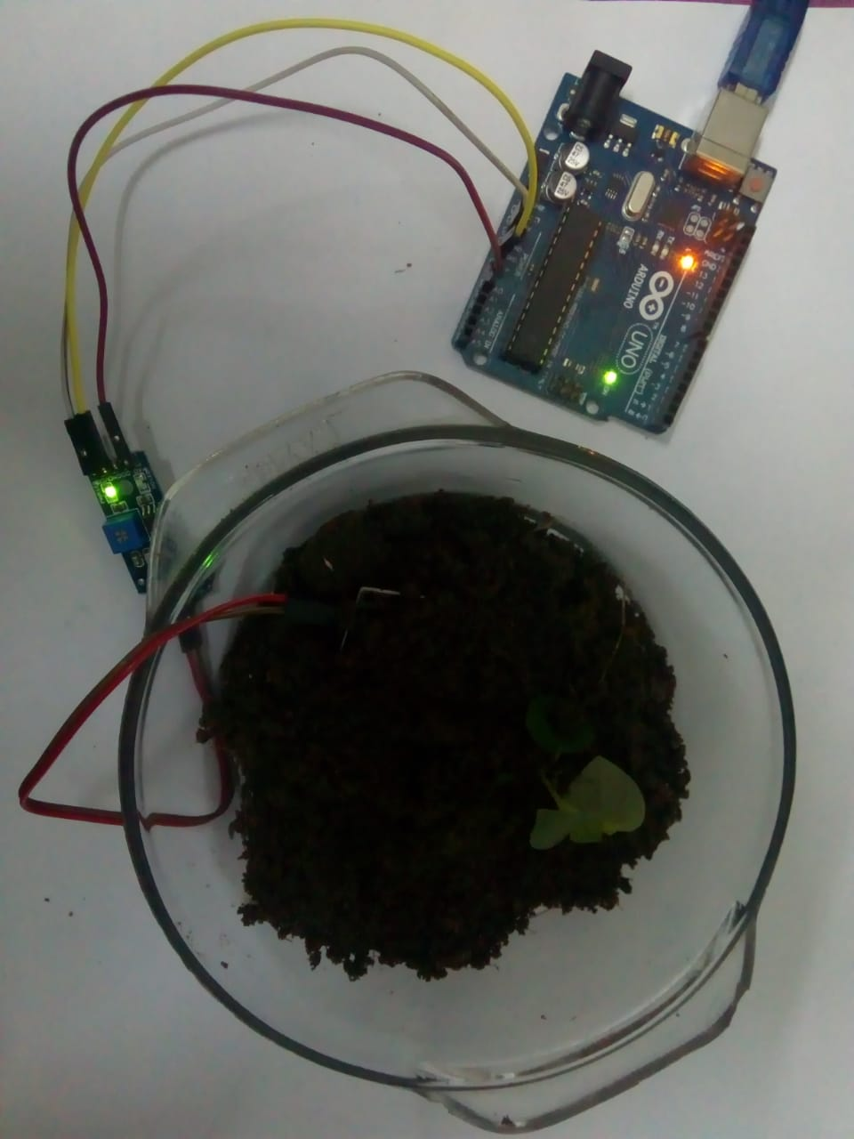

**Connections made:**

1. **The LCD-Arduino circuit**:

* LCD RS pin to digital pin 12
* LCD Enable pin to digital pin 11
* LCD D4 pin to digital pin 5
* LCD D5 pin to digital pin 4
* LCD D6 pin to digital pin 3
* LCD D7 pin to digital pin 2
* LCD R/W pin to ground
* 10K resistor
* Ends to +5V and ground
* Wiper to LCD VO pin (pin 3)

1. **Soil moisture sensor – Arduino circuit:**

* Input pin to analog pin A1.
* VCC to 5V.
* GND to GND.

1. **Servomotor-Arduino circuit**:

* Output pin to digital pin 8.
* VCC to 5V.
* GND pin to GND

**SECURITY SYSTEM**

**Aim: To make a security system i.e. locker using 4*4 keypad matrix and Arduino**

# Components Required:

* 4×4 keypad
* [Arduino Uno](https://electrosome.com/arduino-uno/)
* Power Supply
* Breadboard
* Buzzer
* Connecting wires

**Utility Of The Model:**

As thefts are increasing day by day security is becoming a major concern nowadays. In this project we will make a digital door lock system with keypad using [Arduino Uno](https://electrosome.com/arduino-uno/). It will open your door only when the right password is entered and it will start beeping when a wrong password is entered.

**Working:**

First of all we download the keypad library in the Arduino. We store a permanent password as a string. Now as the user starts entering the each key, that key is stored in the temporary password as soon as user has entered the password if he/she presses ‘*’,then this password is matched with the permanent password stored. If the password entered by the user is same as the password stored then the green LED is switched on and if the password doesn’t match then the buzzer is switched on and the access to the security system is denied. By mistake if the user has entered a wrong password then he can clear that by pressing ‘#’.

The hardware connections done are stated below

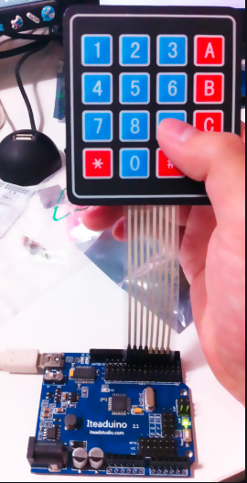

**Connections Made:**

* The keypad has 8 pins, 4 of them are for the rows and other 4 pin for the columns.
* The keypad I'm using is 4x4.
* The Keypad's pins will be connected respectively to the Digital 1-2-3-4-5-6-7-8 pin of the Arduino.
* The LED will be attached on the breadboard
* The LED cathode leg will be connected to the GND of the breadboard.
* The LED resistor leg will be connected to the Digital 10-11 of the Arduino.

**CURTAIN RAISER USING LDR**

**Aim: To adjust the curtain settings according to the day/night time in an unmanned order.**

**Requirements for the model:**

1. LDR Light Sensor module
2. Arduino UNO
3. USB cable
4. Jumper wires
5. DC motor
6. Cloth material
7. Thin iron rod
8. LED bulb
9. 9V battery snap
10. Breadboard

**Utility of the model:**

This part of the model will save electricity and also contribute in utilisation of the natural light in your house. Further it’s a highly efficient system to control the light only when required in a room which is mostly favoured during the night time and saves the wastage of resources during the day time especially. The curtains will open only when in need that is during the day time to allow the sunlight to enter through the room and will automatically shuts the curtain down during the night time and switch on the LED bulb on its own to prevent mechanical work for a person and will also saves time. It will create a smart home which will urge the members of the home to utilise the natural resources i.e. the solar energy properly and thus also will help the person in cost cutting too.

**Working of the model:**

During the night time when it’s dark inside the room, the LDR sensor will sense the darkness and send the signal via Arduino to the DC motor to roll-down the curtains attached onto a thin iron rod and light the LED bulb ON. While throughout the day time, the LDR sensor will sense the light outside the room i.e. the sunlight and will send a signal to the DC motor to roll-up the curtains and turn the LED bulb OFF to allow the natural light to enter the room and brighten it up automatically.

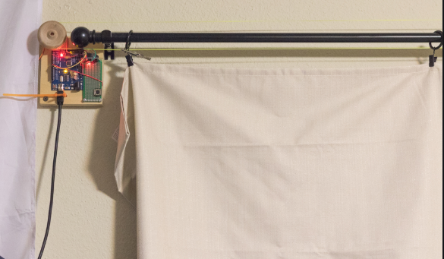

**Connections made:**

1. LDR sensor- Arduino circuit:

* Input pin to Digital pin 7.
* VCC to 5V.
* GND to GND.

2. DC motor-Arduino circuit:

* Output pin 1 to Digital pin 9.
* Output pin 2 to Digital pin 11.
* VCC to 5 V.
* GND to GND.

3. LED bulb – Arduino circuit:

* Terminal 1 to Digital pin 13.
* Terminal 2 to 5V.

**AUTOMATIC DOOR USING PIR SENSOR**

**AIM: To open the front door of smart home.**

**Requirements for the model**:

1. Arduino Uno

2. Servo motor

3. PIR Sensor

4. Jumper Wires

5. 9 V Battery snap

6. USB cord

7. Door lock

**Utility of the model**:

The utility of this part of the model is to provide an entrance to the Smart home. The main feature of this door is that it is operating automatically. With the advancement in technology there has been a shift from more manual labour to more technological labour. This door opens automatically without manual input. This reduction in manual work makes it a more efficient and easy to use door.

**Working of the model**:

The door is made by cardboard material. There are 2 cardboard cutout pieces of same dimensions, One acts as the door holder to which it gets attached when being in closed form. The other acts as the door itself. The cardboard piece used as holder contains a lock which is attached to the door used to open and close the door. The holder of the door is attached to the wire of the servomotor. A PIR sensor is attached on the door which acts as the detection device and as soon as an object is placed in its range it senses it. Servo Motor is a device which is used to convert Electrical energy into Mechanical energy.. For opening the door we have to provide motion of the lock at an angle. Hence, we use a servomotor. The Servomotor is a type of motor which is used to provide mechanical motion at an angle. The Servomotor is attached to the lock. When the

required code of the servomotor is compiled and uploaded, it rotates at an angle giving rotation to the lock piece and this is how the door is opened.

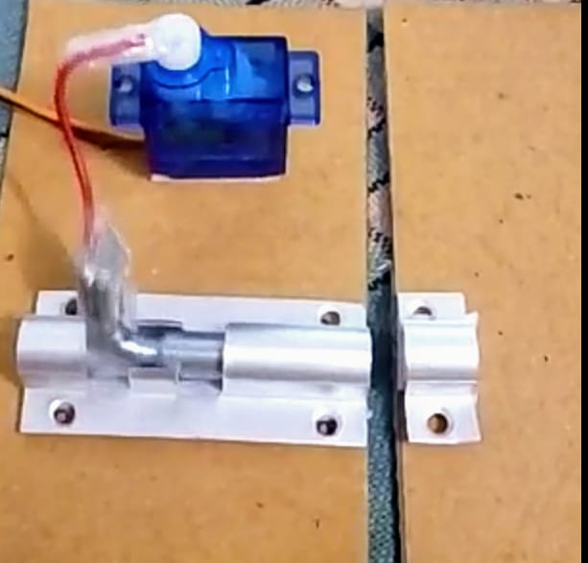

**Connections Made:**

* PIR Sensor to GPIO pin 12
* Servo Motor to GPIO pin 6
* Vcc to 5V.
* GND to GND

**TEMPERATURE AND HUMIDITY DETECTION**

**AIM: To detect the temperature and humidity of a room using DHT11 Sensor**

**Components Required:**

* DHT11 Sensor
* 16x2 LCD
* Jumper Wires
* Bread Board
* Arduino UNO
* Power Supply

**Utility Of The Model:**

DHT11 Temperature & Humidity Sensor features a temperature & humidity sensor complex with a calibrated digital signal output. By using the exclusive digital-signal-acquisition technique and temperature & humidity sensing technology, it ensures high reliability and excellent long-term stability. This sensor includes a resistive-type humidity measurement component and an NTC temperature measurement component, and connects to a high performance 8-bit microcontroller, offering excellent quality, fast response, anti-interference ability and cost-effectiveness.

**Working:**

The DHT11 calculates relative humidity by measuring the electrical resistance between two electrodes. The humidity sensing component of the DHT11 is a moisture holding substrate with the electrodes applied to the surface. When water vapor is absorbed by the substrate, ions are released by the substrate which increases the conductivity between the electrodes. The change in resistance between the two electrodes is proportional to the relative humidity. Higher relative humidity decreases the resistance between the electrodes while lower relative humidity increases the resistance between the electrodes. The DHT11 converts the resistance measurement to relative humidity on an chip mounted to the back of the unit and transmits the humidity and temperature readings directly to the Arduino Nano.

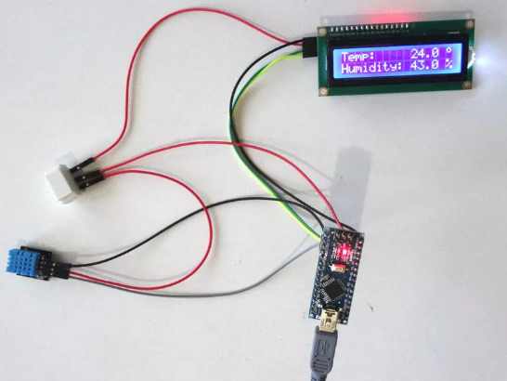

**Connections Made**:

1. **LCD**

* LCD RS pin to digital pin 12
* LCD Enable pin to digital pin 11
* LCD D4 pin to digital pin 5
* LCD D5 pin to digital pin 4
* LCD D6 pin to digital pin 3
* LCD D7 pin to digital pin 2
* LCD R/W pin to ground
* 10K resistor
* Ends to +5V and ground
* Wiper to LCD VO pin (pin 3)

1. **Vcc to Vcc**
2. **GND to GND**
3. **The Pin 2 of DHT 11 Sensor is connected one of the GPIO Pins of the Arduino**

**BIBLIOGRAPHY**

* <https://internetofthingsagenda.techtarget.com>
* Embedded Systems And Robotics-Basics And Advanced (HPE-ERB&A-v1.0)
* <https://www.techopedia.com/definition/3636/embedded-system>
* <https://en.wikipedia.org/wiki/Embedded_system>
* <http://www.circuitstoday.com>
* <http://www.resistorguide.com>
* <https://www.electronicshub.org>
* Electronics Made Easy